Comp2151-Agile Software Development

Lab 04

Group 19:

Baek, Yoo Kyung 101282741

Hughes, Jesse 101244671

Jose, Naveen 101238395

Ngo, Tan Loi 101094358

Wang, Ke 101270848

Wang, Xiaolin 101283366

**Date submitted:**

Feb 21, 2021

**Task 1: A prioritized product backlog for ABC clinic.**

|  |  |  |  |  |
| --- | --- | --- | --- | --- |
| Priority | Product Backlog Items | User Story # | User Story | Story Point |
| 3 | Employee Address | 1 | As a founder of clinic, I want to be able to access data of employees, so that I can prepare a payroll and make it easier for accountant to track hours of works. | 10 |
| 1 | Patient Log | 2 | As a founder of clinic, I want to be able to store patients’ information electronically, so that clinic follows governmental regulation. | 16 |
| 4 | Patient Track Database | 3 | As a receptionist, I want to be able to manage client’s status of visiting clinic electronically, so that clinic can track of which patient have to pay fine or reschedule. | 14 |
| 7 | Examination Room | 4 | As a nurse, I want to have separate space for gathering basic health information of patients prior to watch doctor, so that I can brief doctors about symptoms prior to prescription of medicine or further check up. | 1 |
| 5 | Employee Hours | 5 | As a manager, I want to manage schedules of employees (both non salaries and salaries) electronically, so that I can collaborate with accounting firm and other company who oversee payrolls. | 4 |
| 2 | Staff Information | 6 | As the founder of the clinic, I hope to store all the medical staff information of the clinic in the system. Holiday benefits can also be applied for in the system, so that employees can allocate holiday time by themselves and reduce the manager’s time. | 10 |
| 8 | Appointment Fee | 7 | As a receptionist, I want patients to pay the appointment fee. If they miss it and do not cancel and reschedule, so that can make the patient come to the clinic on time. Other patients will also have more time periods to choose. | 2 |
| 9 | Personal Account | 8 | As an employee, I hope that all salary and remaining vacation time will be displayed on the personal account, so that employees can inquire about direct wages and unused vacations in time. | 1 |
| 10 | Clinic APP | 9 | As the founder of the clinic, I hope that the clinic can provide a clinic application program, so that patients can directly make appointments online, cancel and reschedule, so that reduces the burden on receptionists and improves efficiency. | 8 |
| 6 | New Patients | 10 | As a receptionist, I hope that the personal information of new patients can be directly registered and stored in the system to become a permanent patient, so that can save patients' time and make the operation easier. | 9 |

**Task 2: MoSCoW model.**

|  |
| --- |
| Mo |

**Must Have**

-Patient Log.

- New patients.

- Examination Room.

|  |
| --- |
| S |

**Should Have**

- Employee Hours.

- Patient Track Database.

- Clinic APP.

- Online Cconsultation.

|  |
| --- |
| Co |

**Could Have**

**-** Staff Information.

- Appointment Fee.

|  |
| --- |
| W |

**Won’t Have**

**-** Employee Address.

**Task 3: Story to Task mapping**

**User Story:** As a founder of clinic, I want to be able to access data of employees, so that I can prepare a payroll and make it easier for accountant to track hours of works.

**Tasks:**

1. Access basic information of all employees. (name, phone number, address)
2. Monthly report of clinic status can be found in the file.
3. Use cloud data to track work hours of employee.
4. All employee information is stored in a database (SQL)
5. Employee information can be updated by themselve.

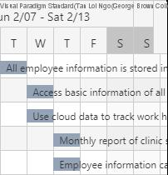

**User Story:** As a founder of clinic, I want to be able to store patients’ information electronically, so that clinic follows governmental regulation**.**

**Tasks:**

1. Information of patient is stored in cloud data and shared with government by regulation.
2. All of visit and prescription history is stored in a database server.
3. Share data from patient track database and determine if patient needs to pay any missed appointment fee.
4. Only necessary information will be going to share with government.
5. Monthly report of how many patients have visited to the clinic will be generated.



**User Story:** As a receptionist, I want to be able to manage client’s status of visiting clinic electronically, so that clinic can track of which patient have to pay fine or reschedule.

**Tasks:**

1. You can add and modify the appointment time online.
2. All expenses are done online.
3. Use cloud data to schedule patient appointments.
4. All patient information is stored in a database (SQL)
5. Contact all patients by email.

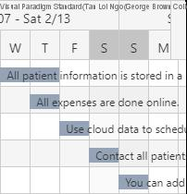

**User Story:** As a nurse, I want to have separate space for gathering basic health information of patients prior to watch doctor, so that I can brief doctors about symptoms prior to prescription of medicine or further check up.

**Tasks:**

1. Use a separate room to collect patient information before the patient sees a doctor.
2. Use the emergency room to collect symptoms from the patient.
3. Feedback all patient information to the doctor.
4. Check again the prescription drugs prescribed by the doctor.
5. The nurse fetches medicine for the patient.

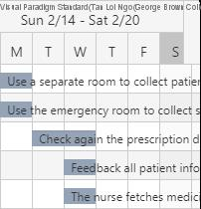

**User Story:** As a manager, I want to manage schedules of employees (both non salaries and salaries) electronically, so that I can collaborate with accounting firm and other company who oversee payrolls.

**Tasks:**

1. Use the database to record employee attendance.
2. Use EXCEL to organize salary.
3. Use EXCEL to record hospital expenses to facilitate tax declaration.
4. Set up a separate volunteer database.
5. Set up a separate database and record it in the cooperation of other companies responsible for payroll.

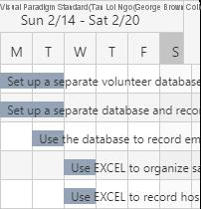

**User Story:** As the founder of the clinic, I hope to store all the medical staff information of the clinic in the system. Holiday benefits can also be applied for in the system, so that employees can allocate holiday time by themselves and reduce the manager’s time.

**Tasks:**

1. Use a database to store employee information.
2. Reasonably plan vacation time.
3. Employees can directly apply for leave on the system.
4. The manager can directly approve vacation, sick leave, etc. at the back end of the system.
5. Invest in programming software such as JAVA to manage the database.

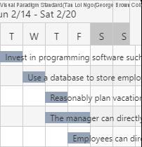

**User Story:** As a receptionist, I want patients to pay the appointment fee. If they miss it and do not cancel and reschedule, so that can make the patient come to the clinic on time. Other patients will also have more time periods to choose.

**Tasks:**

1. All information is stored on PHP MySQL after patients booked an appointment.
2. The system will send an email to patients to remind their schedule.
3. Patients can go online or call the front desk to cancel or reschedule their appointments.
4. The system will charge $30 if patients no show or missed an appointment.
5. Patients can pay their fine on the website or at the front desk.

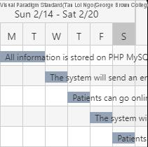

**User Story:** As an employee, I hope that all salary and remaining vacation time will be displayed on the personal account, so that employees can inquire about direct wages and unused vacations in time.

**Tasks:**

1. Employee information such as personal information, salary, schedule, vacation is stored in PHP MySQL.
2. Create classes and pages related to employee on PHP Storm software.
3. Fix the bugs in the code and testing on employee pages.
4. Employees need to login before viewing their information such as salary, schedule…
5. Export schedule to word and salary to excel file.

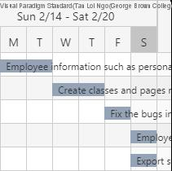

**User Story:** As the founder of the clinic, I hope that the clinic can provide a clinic application program, so that patients can directly make appointments online, cancel and reschedule, so that reduces the burden on receptionists and improves efficiency.

**Tasks:**

1. Install php storm on team members’ laptops for creating web pages.
2. Create a database by using PHP MySQL to connect and retrieve data from relevant tables in the database.
3. Create classes that contain functions such as booking, cancellation, rescheduled using C#.
4. Create web pages, patient page includes log-in, booking, cancel, and reschedule.
5. Fix the bugs in the code, found during testing.
6. Test booking, cancel and reschedule an appointment as patient on the website.

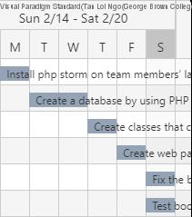

**User Story:** As a receptionist, I hope that the personal information of new patients can be directly registered and stored in the system to become a permanent patient, so that can save patients' time and make the operation easier.

**Tasks:**

1. Create a registration table on PHP MySQL to store patient information.
2. Create a Registration class on PHP Storm software.
3. Create a Registration page for patients who want to sign up to be permanent patients.
4. Fix the bugs in the Registration class and Html code.
5. Testing registers a permanent patient on the Registration web page.
6. Store data into PHP MySQL after registered.

